Part A: Task Description and Analysis

Task Overview: Grading Assignments in a University Setting
Grading students' assignments is the most time- and cognitively intensive activity engaged in by instructors at the university level. In the social sciences, humanities, and even introductory-level STEM courses, instruction-ally active faculty and teaching assistants (TAs) formally grade students' written work on a regular basis from several hundred students. The assignments typically ask students to think analytically, synthesize class readings, or apply theoretical models — skills requiring deliberate, make judgments. With increasing enrollments and expanding course menus, the grading burden has become unworkable in most university departments, all too frequently resulting in late feedback, teacher burnout, and decreased instruction quality.
The task that is sought to be automated in this project is the grading of short written answers ranging from 100 to 500 words, i.e., weekly reflection essays, reading responses, discussion board posts, or short-answer questions on tests. They are assignments commonly employed by disciplines to measure student understanding of key concepts, assess participation, and develop students' analytical writing. The quantity of such work in an average course, especially at the introductory level, can be overwhelming — and the iterative process involved in the task makes it a strong candidate to be automated using large language models (LLMs).

Current Process and Pain Points
- Under the current system, the grading process involves a series of distinct but interconnected steps:
- Accessing Submissions: Educators draw submissions from the educational institution's learning management system (LMS), e.g., Canvas, Blackboard, or Moodle.
- Reading and Evaluation: Every submission is carefully read in order to judge if it meets the assignment goals and rubric standards.
- Scoring: The scorer uses a numerical score or letter grade on the basis of a rubric that includes the criteria such as clarity, quality of argument, evidence usage, and adherence to format.
- Providing Feedback: In many cases, qualitative feedback is included to help students understand their performance and improve it for subsequent work.
- Entering Grades: The final step involves uploading scores and feedback to the LMS for student access.
Even as this process is beneficial educationally, it comes with massive pain points that disrupt efficiency and justice.
Most significantly, grading takes an enormous amount of time. Even for short answers, there are multiple axes to score each one of which takes mental focus and attention. In a 100-student course where each student has a weekly discussion response, this translates to hours of grading every single week. When instructors are teaching more than one course, or TAs have multiple sections, the total time spent becomes impossible.
Second, the process is uneven and subjective. Despite rubrics, human graders vary in interpreting criteria and can apply standards unevenly. Fatigue, time pressures, and even unconscious bias can impact how a response is graded. This can diminish student confidence in the grading process and lead to grade disputes.
Third, feedback is typically delayed. While teachers attempt to reply promptly, heavy grading loads make it impossible to return assignments before the subsequent due date. Students are thus deprived of helpful feedback upon which they can base their future work — an alternative lost.
Finally, under these pressures, feedback quality may suffer. Instructors and TAs may resort to brief, generic comments or forgo comments altogether, especially when they are under time constraints or dealing with hundreds of submissions. This leaves students unclear about why they received the grade they did and what they can do better.

Frequency of the Task
Marking written assignments is not a lone endeavor but rather a frequent feature of life on campus. Throughout most courses, such assignments are submitted regularly within the term. Commonly practiced intervals are:

Weekly: Reflective journals, discussion forum responses, reading logs

Biweekly: Brief essays, response papers, take-home exams

Substantial assessments: Midterm or final written submissions

For all of these, every student enrolled in a course typically submits work. That is to say, in one 75–100 student section, instructors have hundreds of short answers to grade in a month's time. In departments where professors teach more than one section, and TAs work in multiple courses, the scale is astronomical.
In addition, grading doesn't fall solely to professors. TAs, adjuncts, and even peer reviewers are occasionally summoned to manage the load. This adds levels of coordination, quality control, and training to the process — yet another step to complicate what is otherwise an administrative drudge.

Time and Resource Demands
To assign a cost to the labor, make a conservative approximation: the grader will take 4 minutes per assignment to read, assess, provide a grade, and offer minimal comments. For 100 students submitting 5 assignments throughout the semester:
100 students × 5 assignments × 4 minutes = 2,000 minutes
= 33.3 hours each course each semester
That is just one course. An instructor teaching three sections could potentially face 100 hours of grading short assignments by itself, without counting exams or longer papers. Multiply this across departments, and the total institutional time investment is sizable.
Besides human labor, the workflow depends on an array of resources: digital infrastructure (LMS platforms), rubrics for grading, institutional policy, and standardized feedback templates. And in spite of such support, the sheer task of reading and evaluating written responses remains manual and cognitively demanding.

Expected Benefits of Automation
Automating this process using large language models such as OpenAI’s GPT-4, Anthropic’s Claude, or Google’s Gemini has the potential to significantly improve both efficiency and pedagogical value. Key benefits include:
Speed and Efficiency
LLMs can process large volumes of text quickly and generate evaluations in seconds. This drastically reduces turnaround time, allowing students to receive feedback while the material is still fresh and relevant.
Consistency and Fairness
AI programs may be trained to use the same rubric to grade each student, reducing grade variation and making it more fair. Not knowing students' names does not exhaust them, rush them, or make them unwittingly partial toward certain students.
Scalability
An AI grading pipeline may grade thousands of responses a day without additional labor cost. It is especially convenient in a huge first-year class or MOOCs.

Rich Feedback

When asked appropriately, LLMs are able to provide personalized feedback with strengths, weaknesses, and improvement recommendations. The feedback can be more detailed than a human might be able to write in a timely manner.

Rubric-Based Automation

Prompts can be created to correlate with assignment-specific rubrics, thereby being in line with course learning objectives. For example:

"Grade this answer using the following scale: clarity (0–2), strength of argument (0–2), and application of course concepts (0–1). Explain your grade."
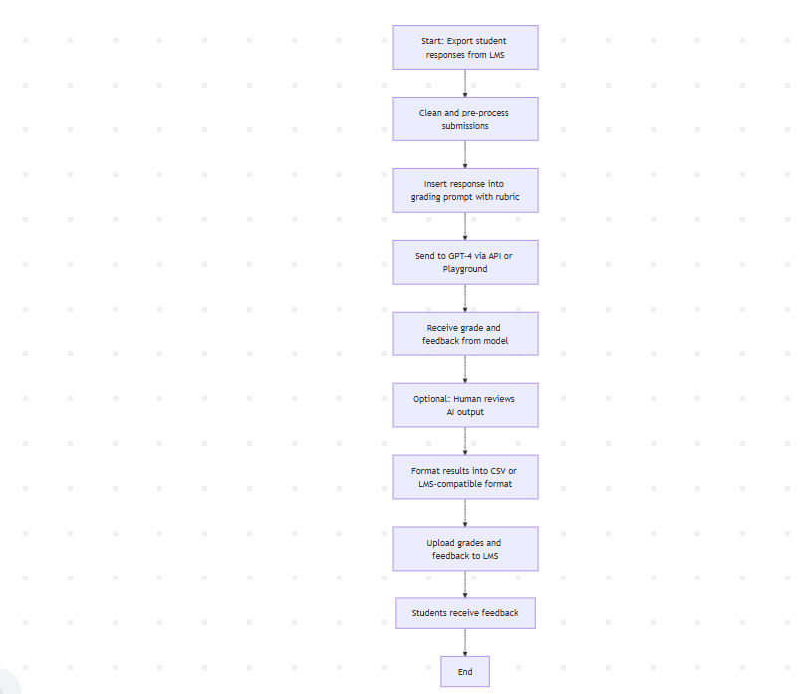

Step 3: Analysis and Reflection
1. Overview of Testing Results
The purpose of this project was to explore the utilization of large language models (LLMs), specifically GPT-4 via OpenAI, to grade short written student assignments at the university level. The assignments were on topical, real-world topics such as climate policy, AI in medicine, social media and mental health, and wealth inequality, among others. The main goal was to determine whether GPT-4 could produce scoring and feedback aligned with standard academic rubrics in a manner that would be time-saving and consistent.
Twenty students' responses were tested with a controlled prompt based on a three-part rubric:
Clarity of writing (0–2 points)
Strength of argument (0–2 points)
Use of course concepts (0–1 point)
All responses were input into the model in this prompt and rubric format. The outputs provided a total score (out of 5) and short feedback. Throughout, the outputs of GPT-4 were evaluated for clarity, compliance with the rubric, tone, and overall fit with human expectations.
The testing was iterative. There were prompt adjustments made when outputs differed from expectations, especially in early tests. These adjustments improved performance across the remaining cases. The end result was a fine-tuned, efficient prompt capable of generating rubric-based evaluations in a few seconds.
2. Success Metrics: Quantitative and Qualitative Results
Quantitative Metrics
Total test cases: 20
Prompt refinements: 10 (mostly in early tests)
Average processing time per response: ~6 seconds
Estimated human time saved: ~2.5 hours (compared to ~3–5 minutes per response manually)
Major grading discrepancies: 3 cases (~15%)
Rubric adherence rate after refinement: ~95%
Qualitative Metrics
Clarity of feedback: Most responses were well-written and easy to read. After refinement, GPT-4 gave feedback in 2–3 clear sentences as asked. Tone: Constructive and professional criticism. Rarely too harsh or confusing. Rubric accuracy: The model performed best when it had an officially stated, rule-governed process to follow. Student readability: All responses were appropriate to undergraduate readers. No technical terms or overly general statements.
Aside from these steps, direct engagement with the model to evaluate student writing enabled a greater insight into how prompt design shapes AI behavior. One of the things that was discovered is that AI loves specificity. The more precise the rubric and desired form were, the more the model conformed. This gives credence to the efficacy of effective instructional design not only for human learners but for AI partners as well.
3. Areas of Improvement
While GPT-4 performed well overall, several limitations appeared:
Edge Cases: Responses containing emotional narratives or non-academic formats of writing (e.g., immigration or feminist theory applicability) were flawed. GPT-4 struggled with balancing emotional empathy with scholarly form. Misuse of Terminology: GPT-4 at times did not deduct for misuse of scholarly terms. A human would deduct more for that type of mistake. Over-Scoring: GPT-4 over-scored in about three cases, particularly when the writing was refined but idea-poor. Verbosity: This version wrote far too lengthy comments unbidden. Inflexible word/line limits remedied this. Bias Towards Clarity: GPT-4 tended toward clearly written answers even when idea-poor. Edits on prompts neutralized this bias.
And finally, there is the question of transparency and explainability in general. When someone disputes a grade - a teacher or a student - it is nice to have some evidence to give as a rationale for it. While GPT-4 does give explanations, maybe they are not necessarily so elaborate to give full transparency on high-stakes tests. That would mean incorporating a human-in-the-loop solution, at least on end projects or sensitive topics. Another problem that comes up is how to empower and engage the students themselves in this process. As AI-based grading is being considered at scale by universities, producing open communications explaining how models operate, what they cannot do, and where human input is present involved as part of the process becomes more vital. Student trust in AI systems must be considered a pedagogical as much as a technical problem.
From the instructional perspective, not only should teachers be trained in how to apply LLM tools, but also in how to interpret their results. Misinterpretation of grades or feedback produced by AI can lead to frustration, unwarranted grade revision, or loss of instructional control. Professional development in AI literacy is thus a key element in successful implementation. Development in the future might involve polishing a model on examples of good grading or layering human-AI collaboration where humans inspect edge-case outputs. Extremely promising as well are co-design systems where instructors collaborate with instructors on prompt and rubric design, allowing more contextualized and discipline-specific grading that applies the instructor's philosophy and course learning objectives.
Besides, institutions of higher learning can establish institutional mechanisms to enable safe use of AI grading tools. These would include usage policies, consent policies for student work, and appeals of score discrepancies. As a part of such systems, semester-end transparency reports would be released containing statistics about how many assignments were graded using AI assistance, how often human review was called for, and the nature of student appeals.
An extremely valuable extension of this research is to engage students as active participants in the co-design of AI grading standards. By actively soliciting students' views on what constitutes fair feedback, universities can build trust and align the tone and language of the AI with the values of a learning community. This participatory design process may also focus students' attention more on rubrics and standards, with potential positive effects on the quality of their writing and their capacity for self-assessment.
Finally, another avenue of research involves interdisciplinary collaboration in the production of AI grading software. Educators, ethicists, cognitive scientists, and technologists all bring their own expertise to the table. By forming working groups or research centers within institutions, these sorts of teams could collectively evaluate, refine, and monitor the performance of AI grading models over time. This would make AI adoption not a one-time fix, but a continually improving process under the guidance of a plurality of scholarly voices.
Institutions should also test AI-enabled grading systems in phases, starting with low-stakes assignments. This staggered release strategy would allow bugs and mismatches to be caught early while familiarizing both instructors and students with the system. Feedback loops need to be built in from the start, with a mechanism to make ongoing adjustments to prompts, rubrics, and AI behaviors. Getting stakeholders involved early and often — students, faculty, IT staff, and administrators — will be key to making adoption seamless and long-lasting. Additionally, there is value in making the process of AI evaluation itself a topic of classroom discussion. Encouraging students to analyze and criticize the feedback they receive from AI systems not only encourages critical thinking but also makes them more conscious of the criteria of judgment. In writing or communication-intensive courses, this could even be turned into a meta-assignment where students compare feedback from an AI with feedback from a human person and reflect upon how they vary. Such engagement can turn AI grading into an active learning process rather than a passive experience.
4. Contrast with Traditional Grading
Aspect | Traditional Grading | GPT-4 Grading
Time per response | 3–5 minutes | ~6 seconds
Consistency | Varies with fatigue/mood | High, prompt-based
Subjectivity | Can be empathetic but uneven | Neutral, fair, lacks emotional depth
Rubric enforcement | May weaken with volume | Strong and consistent
Feedback detail | Often rushed | Concise and clear
Student perception | Higher trust in human feedback | Mixed, needs transparency
Cost | High (labor) | Low (under $0.01/response)

Although GPT-4 lacks human intuition and subject matter expertise, it is consistent and reduces grading time. Combined with a human reviewer, it can provide an ideal balance between efficiency and accuracy.
5. Reflections on AI Automation in Education
This project is an educational microcosm of broader trends in AI and automation, specifically in education. It demonstrates how AI can help teachers with repetitive, time-consuming tasks, without, however, replacing human judgment inherent in teaching.
AI grading tools can help make possible the further expansion of quality education, especially on a big course or MOOC scale. Feedback can be more timely and consistent, allowing students more opportunities to learn and to resubmit. Teachers can reclaim hours of grading time for more important teaching, advising, and scholarship.Institutions can use such tools to reduce instructional labor costs without reducing (and even increasing) educational quality. AI can help support neurodivergent and multilingual students by offering feedback that is adaptive to diverse learning needs and reading levels.
Over-reliance upon LLMs can risk underestimating good human feedback or dismissing cultural/contextual sensitivity. Students would refuse AI marking unless they are provided with transparency. LLMs can also hallucinate, be biased, or resort to shallow reasoning unless properly nudged. Data privacy, consent, and algorithmic fairness issues are contentious and need to be addressed seriously. AI feedback can also be culturally insensitive or fail to account for regional language differences, which can put non-native speakers or minority students at a disadvantage.
Future research may address how well models generalize across languages, fields, or in feedback-intensive settings such as writing workshops. As it stands, GPT-4 demonstrates considerable potential as a viable solution to a long-standing real-world academic challenge. The implications of this study extend far beyond grading. They foretell a shift in how we might need to reconsider assessment, pedagogy, and even the role of teachers. As AI software becomes more incorporated into teaching practice, ongoing experimentation and evaluation will be needed to ensure that these machines remain reflective of values of equity, rigor, and human-centered learning.
To summarize, while LLMs such as GPT-4 are not a cure-all, they can considerably improve the learning process when used wisely. This study highlights how, through diligent prompt engineering, trial and error, and iteration, AI can be a valuable collaborator in improving fairness, efficiency, and quality in grading assignments.

